**CSC 555 Phase 5**

**Yiyang Yang**

**Part 1**

A.

Hive:

CREATE TABLE lineorder (

lo_orderkey int,

lo_linenumber int,

lo_custkey int,

lo_partkey int,

lo_suppkey int,

lo_orderdate int,

lo_orderpriority String,

lo_shippriority String,

lo_quantity int,

lo_extendedprice int,

lo_ordertotalprice int,

lo_discount int,

lo_revenue int,

lo_supplycost int,

lo_tax int,

lo_commitdate int,

lo_shipmode String)

ROW FORMAT DELIMITED FIELDS TERMINATED BY '|';

LOAD DATA LOCAL INPATH '/home/ec2-user/CSC555Final/Scale4/lineorder.tbl' OVERWRITE INTO TABLE lineorder;

INSERT OVERWRITE LOCAL DIRECTORY '/home/ec2-user/CSC555Final/Scale4/lineorder.csv'

ROW FORMAT DELIMITED FIELDS TERMINATED BY ','

SELECT * FROM lineorder;

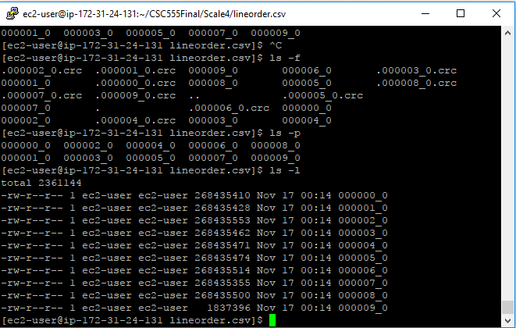

Pig:

lineorderData = LOAD '/FinalData/lineorder.tbl' USING PigStorage('|')

AS (lo_orderkey:int, lo_linenumber:int, lo_custkey:int, lo_partkey:int,

lo_suppkey:int, lo_orderdate:int, lo_orderpriority:chararray, lo_shippriority:chararray,

lo_quantity:int, lo_extendedprice:int, lo_ordertotalprice:int, lo_discount:int,

lo_revenue:int, lo_supplycost:int, lo_tax:int, lo_commitdate:int, lo_shipmode:chararray);

STORE lineorderData INTO '/FinalData/pig' USING PigStorage('\t', '-schema');

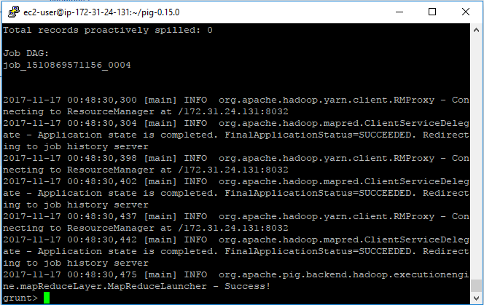

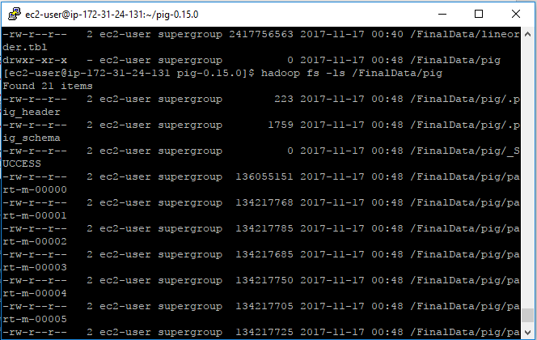

Hadoop Streaming:

mapper4.py

#!/usr/bin/python

import sys

for line in sys.stdin:

w = line.strip().split('|')

print w[0],w[1],w[2],w[3],w[4],w[5],w[6],w[7],w[8],w[9],w[10],w[11],w[12],w[13],w[14],w[15],w[16]

hadoop jar /home/ec2-user/hadoop-2.6.4/hadoop-streaming-2.6.4.jar -input /user/FinalData/lineorder.tbl -output /user/FinalData/output -mapper mapper4.py -file mapper4.py

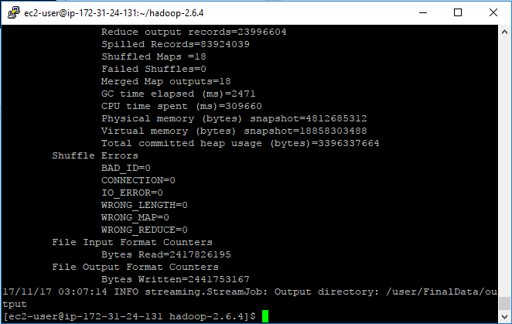

hadoop fs -cat /user/FinalData/output/part-00000 > lineorder.csv

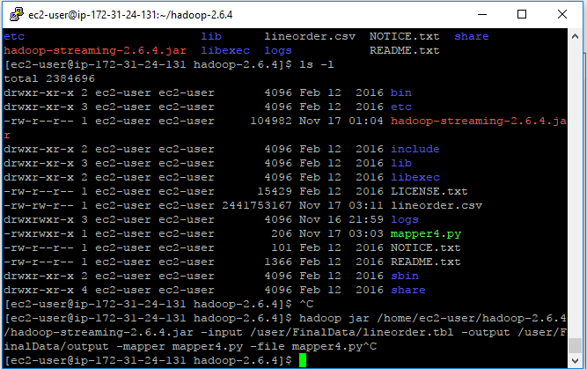

B:

Hive:

INSERT OVERWRITE DIRECTORY 'FiveOutput'

SELECT lo_orderkey, lo_linenumber, lo_partkey, lo_custkey, lo_quantity

FROM lineorder

WHERE lo_discount BETWEEN 4 AND 6;

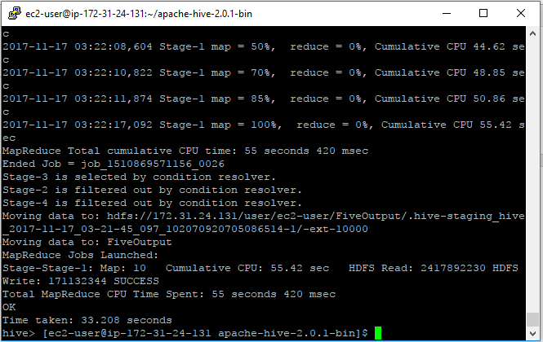

Pig:

lineorder2 = FILTER lineorderData BY lo_discount > 4 AND lo_discount < 6;

FiveOutputP = FOREACH lineorder2 GENERATE lo_orderkey, lo_linenumber, lo_partkey, lo_custkey, lo_quantity;

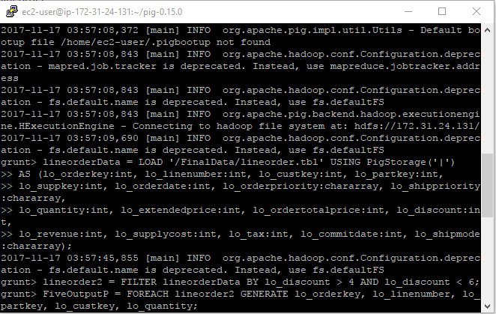

C:

Hive:

INSERT OVERWRITE LOCAL DIRECTORY '/home/ec2-user/CSCFinal/Scale4/output.csv'

ROW FORMAT DELIMITED FIELDS TERMINATED BY ','

SELECT lo_partkey, lo_suppkey, lo_discount, d_year, lo_revenue

FROM lineorder, dwdate

WHERE lo_orderdate = d_datekey;

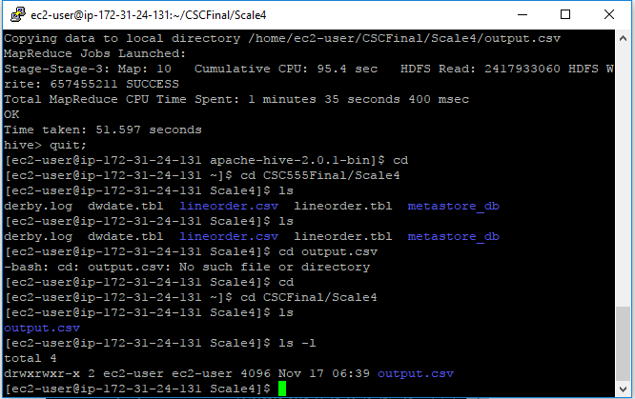

Pig:

lData = LOAD '/FinalData/lineorder.tbl' USING PigStorage('|')

AS (lo_orderkey:int, lo_linenumber:int, lo_custkey:int, lo_partkey:int,

lo_suppkey:int, lo_orderdate:int, lo_orderpriority:chararray, lo_shippriority:chararray,

lo_quantity:int, lo_extendedprice:int, lo_ordertotalprice:int, lo_discount:int,

lo_revenue:int, lo_supplycost:int, lo_tax:int, lo_commitdate:int, lo_shipmode:chararray);

dData = LOAD '/FinalData/dwdate.tbl' USING PigStorage('|')

>> AS(d_datekey:int, d_date:chararray, d_dayofweek:chararray, d_month:chararray,>> d_year:int, d_yearmonthnum:int, d_yearmonth:chararray, d_daynuminweek:int, >> d_daynuminmonth:int, d_daynuminyear:int, d_monthnuminyear:int, d_weeknuminyear:int,

>> d_sellingseason:chararray, d_lastdayinweekfl:chararray, d_lastdayinmonthfl:chararray,

>> d_holidayfl:chararray, d_weekdayfl:chararray);

joinD = JOIN lData BY lo_orderdate LEFT OUTER, dData BY d_datekey;

out = FOREACH joinD GENERATE lo_partkey, lo_suppkey,

lo_discount, d_year, lo_revenue;

STORE out INTO 'Final/pigout' USING PigStorage('\t', '-schema');

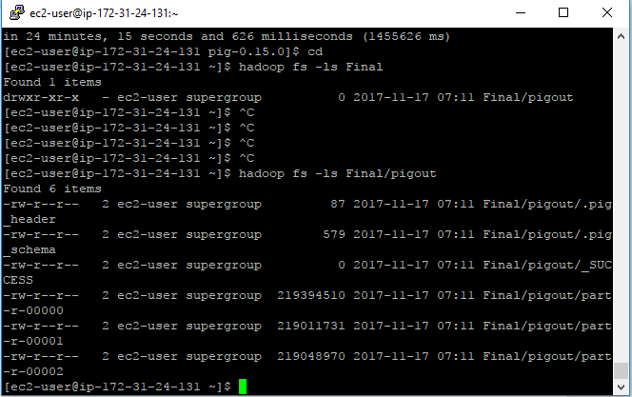

**Part 2**

A: 2.2

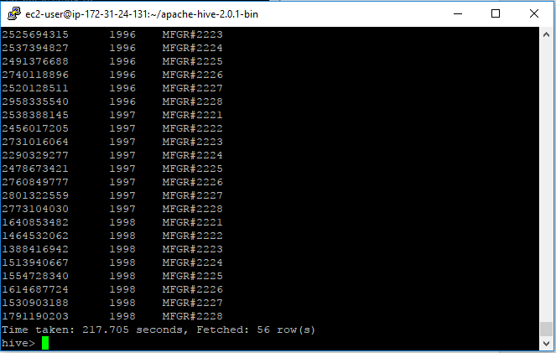

3.2

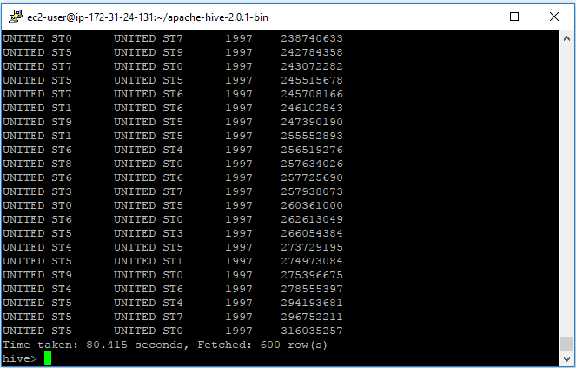

4.2

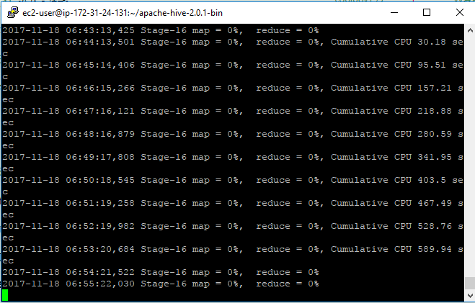

B.

Hive:

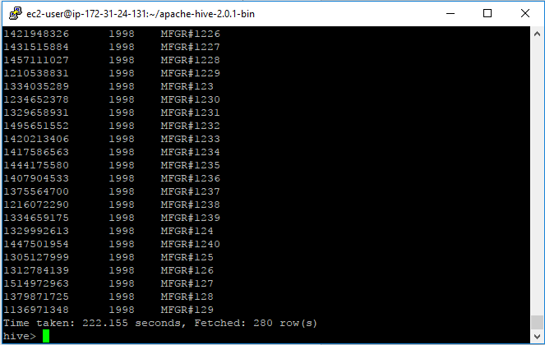

Pig:

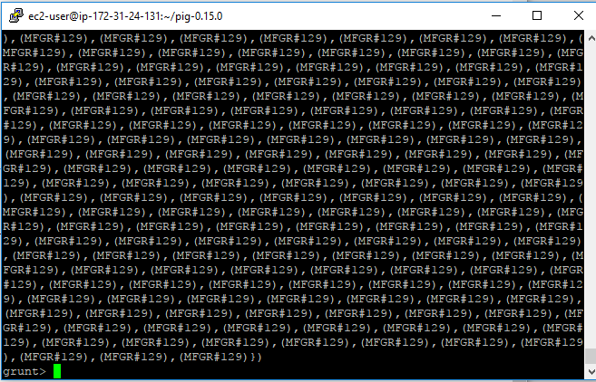

**Part 3**

A.

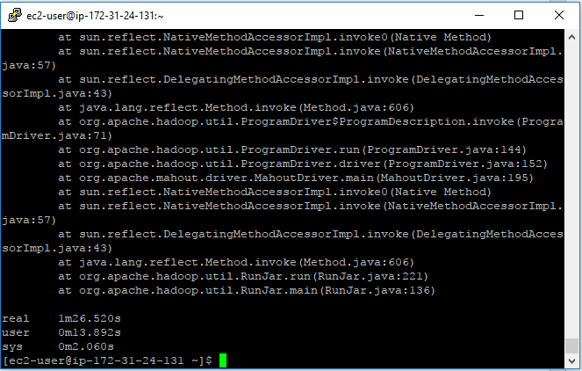

Mapper:

#!/usr/bin/python

import sys

clusters = []

i=0

centers = []

center_index=[]

def get_center(v0, v1, v2, v3, v4):

n_index = None

n_distance = 9999999999

for c in centers:

dist = ((v0 - c[0])**2 + (v1 - c[1])**2 + (v2 - c[2])**2 + (v3 - c[3])**2 + (v4 - c[4])**2 )**0.5

if dist < n_distance;

n_index = i

n_distance = dist

i += 1

return nearest_c_index

for line in sys.stdin:

line = line.strip()

vals = line.split(" ")

if len(vals) == 4:

clusters.append(vals)

else:

center_index=vals

for n in center_index:

centers.append(clusters[n])

n_index = get_center(vals[0], vals[1], vals[2], vals[3], vals[4])

**Part 4**

A.

a.

Hive 4 nodes:



Hive single node:



Pig 4 nodes:

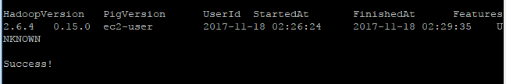

Pig single node:

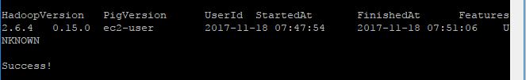

Hadoop Streaming 4 nodes:



Hadoop Streaming single node:

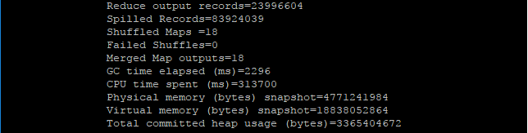

b.

Hive:



Pig:

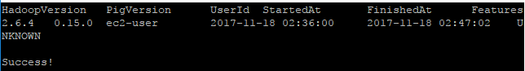

Hadoop Streaming:

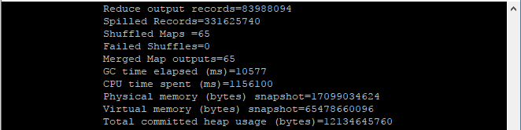

B.

a.

Hive 4 Nodes:



Hive Single node:



Pig 4 Nodes:



Pig single node:



It looks like more nodes can reduce the run time. Larger dataset with multiple nodes will be much faster, but small dataset with single node will be much faster. I think assign the jobs and blocks will need more time.